Project Documentation

**Title:** Comprehensive Analysis and Dietary Strategies with Tableau: A College Food Choices Case Study

Team ID: LTVIP2025TMID50715

Team Size: 4

Team Lead Name: Pochiraju Satya Prasanna Kowlini Shabda Pyari

Team Member: Muripuri Ramesh

Team Member: Perla Kirthana

Team Member: Putti Sri Hari Chandana

**Dataset Used:** food_coded.csv from Kaggle

# 1. Introduction

This project is about analyzing dietary and lifestyle trends among college students through visualization using Tableau. The objective is to derive ideas that can aid in enhancing health and nutrition policies in educational settings.

# 2. Project Objectives

* Analyze food and lifestyle habits among students

* Identify shortages and unhealthy trends

* Visualize data to easily understand

* Offer insights for health interventions

# 3. Dataset Overview

Source: Kaggle ([https://www.kaggle.com/datasets/borapajo/food-choices](https://www.kaggle.com/datasets/borapajo/food-choices))

File Used: food_coded.csv

Number of Records: ~125

Key Fields: Gender, GPA, Diet, Exercise, Vitamins, Food Preferences, Calories, Weight, etc.

# 4. Tools Used

Tableau Public: For visualizations, dashboards, and story

MS Excel/Google Sheets: For data checks initially

MS Word/Google Docs: For documentation

Loom/Zoom/OBS: For video demo recording

# 5. Project Workflow

Step 1: Data Collection

* Downloaded the data set from Kaggle

* Imported food\_coded.csv into Tableau

Step 2: Data Preparation

* Checked data types and cleaned out missing values

* Renamed ambiguous column headers

* Created calculated fields for Total Calorie Intake and Health Index

Step 3: Visualization

Made 22 visualizations, which include:

1.Distribution by Gender

2. Distribution by GPA

3. Breakfast Options

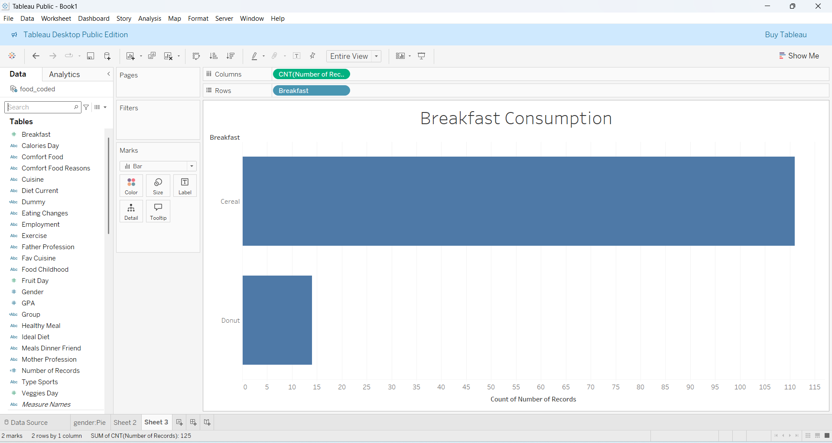

4. Calorie Intake per Day

5. Favorite Comfort Foods

6. Why Comfort Food

7. Weekly Frequency of Cooking

8. Cuisine Preferences

9. Status of Diet Type

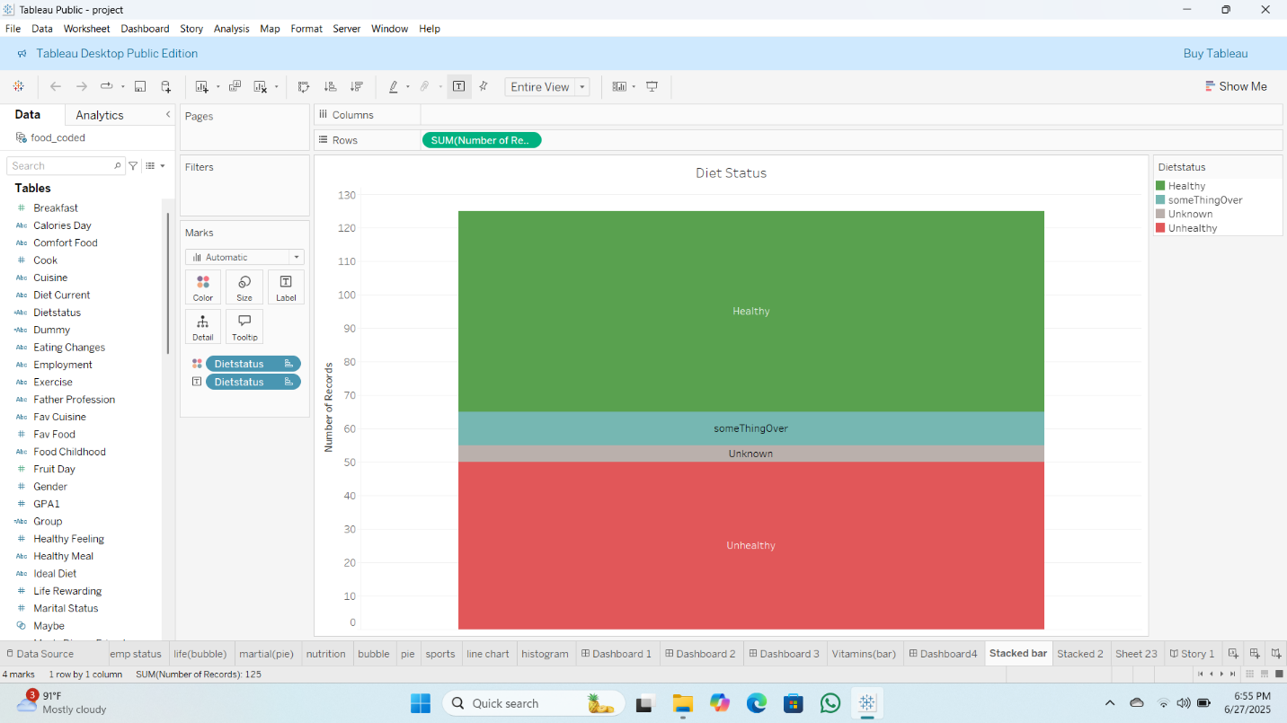

10. Weekly Frequency of Exercise

11. Employment Status

12. Rating of Health Perception

13. Rating of Life Rewarding

14. Marital Status

15. Nutritional Label Reading

16. Parental Cooking Practices

17. Meal Payment Practices

18. Self-Perceived Weight

19. Sports Activity

20. Fruit and Vegetable Eating

21. Vitamin Consumption

22. Weight of Students

Step 4: Dashboard Creation

Created 3 dashboards:

*Health Dashboard: Calorie, Vitamins, Exercise

*Food Preferences Dashboard: Cuisine, Comfort food, Cooking habits

* Lifestyle Dashboard: Employment, GPA, Parental influence

Step 5: Story Creation

Developed a 5-scene story:

Thorough Analysis and Nutrition Strategies with Tableau: A College Food Choices Case Study

Story Point 1: Introduction – Student Nutrition

Title: A Deeper Insight into College Students' Eating Habits

Caption: In this research, we delve into the eating habits of college students, seeking to identify trends in eating habits, nutritional consumption, and lifestyle determinants. Through Tableau, we seek to bring forward actionable findings to ensure healthier lifestyles on campus.

Story Point 2: Dietary Patterns and Preferences

Title: What Do Students Eat? Patterns in Food Choices

Caption: Students tend to eat high-calorie food items such as waffles, Starbucks cones, and burritos. The chart for breakfast shows higher preferences for cereals compared to nutritious fruit-based foods.

Story Point 3: Cooking Habits and Physical Activity

Title: Frequency of Cooking and Lifestyle Habit

Caption: A high percentage of students prepare food only 1–2 times a week and use convenience food. Exercise levels remain variable, which affects general well-being.

Story Point 4: Health Awareness and Self-Perception

Title: Student Perception of Their Health and Diet

Caption: Self-reported information shows many students classify their health as average or poor, with few nutritional checkup habits. Their weight perception is also quite variable, suggesting a lack of awareness.

Story Point 5: Gaps and Concerns – Where We Fall Short

Title: Identifying Nutritional Deficiencies and Risks

Caption: Low fruit and veggie intake, high-calorie snacking, and low vitamin usage are alarming trends. These factors increase the risk of long-term health issues among college students.

Story Point 6: Toward Better Diet Strategies

Title: Proposed Dietary Strategies for Student Health

Caption: Using data insights, universities can build targeted strategies like healthy meal plans, awareness programs, and personalized nutrition guidance to promote healthier choices on campus.

Step 6: Performance Testing

* Data Loaded: 125 rows x 40+ columns

* Visualizations: 22 different charts

* Filters Applied: Gender, GPA, Diet, Exercise

*Calculated Fields: Total Calories, Health Index

Step 7: Web Integration (Optional)

* Published dashboards to Tableau Public

* Embedded story/dashboard in a Flask-based web page using iframe

6. Key Insights

* Students who missed breakfast and did not exercise frequently had low health perception ratings.

* Vitamin consumption was low in non-exercising students.

* High correlation was found between comfort food intake and emotional well-being.

7. Conclusion

This project illustrates how Tableau can be utilized to visualize and analyze college student food choice data. The dashboards and stories present actionable information for institutions to develop improved nutrition plans and awareness campaigns.

8. References

* Kaggle Dataset: [https://www.kaggle.com/datasets/borapajo/food-choices](https://www.kaggle.com/datasets/borapajo/food-choices)

* Tableau Documentation

* Public Health & Nutrition Journals